DAY 3

Q1)

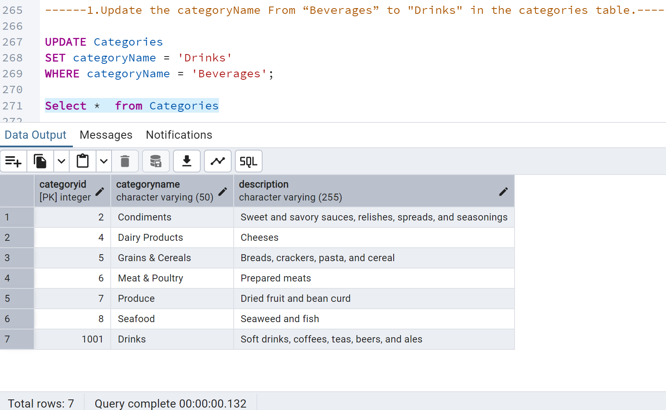

Q2)

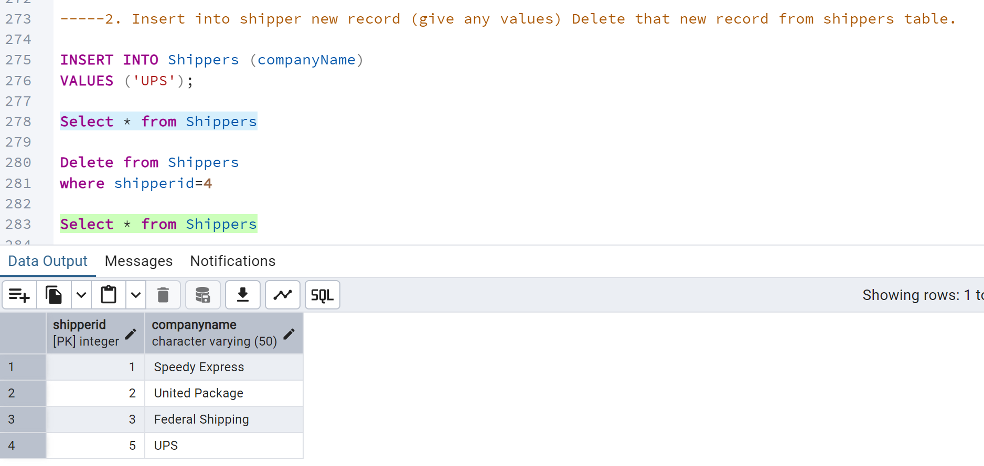

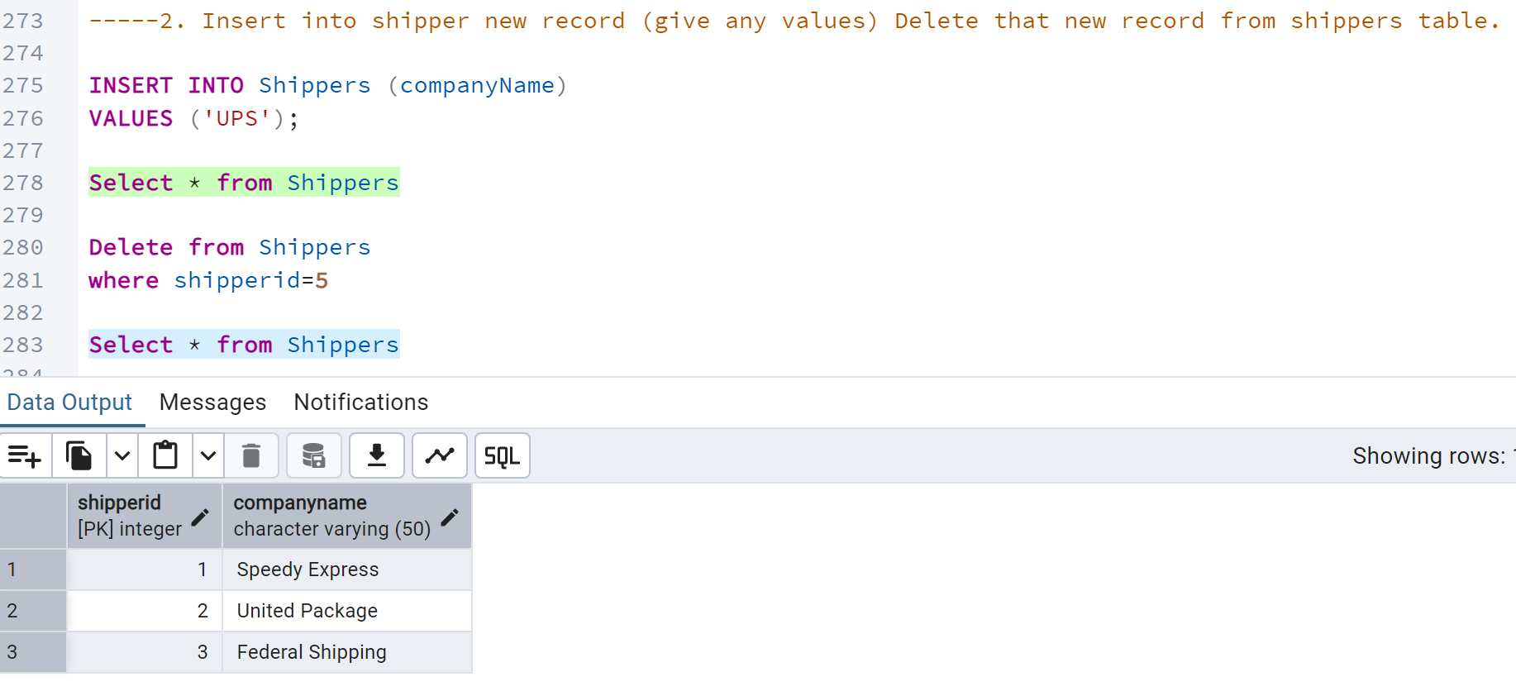

Q.3) categories table

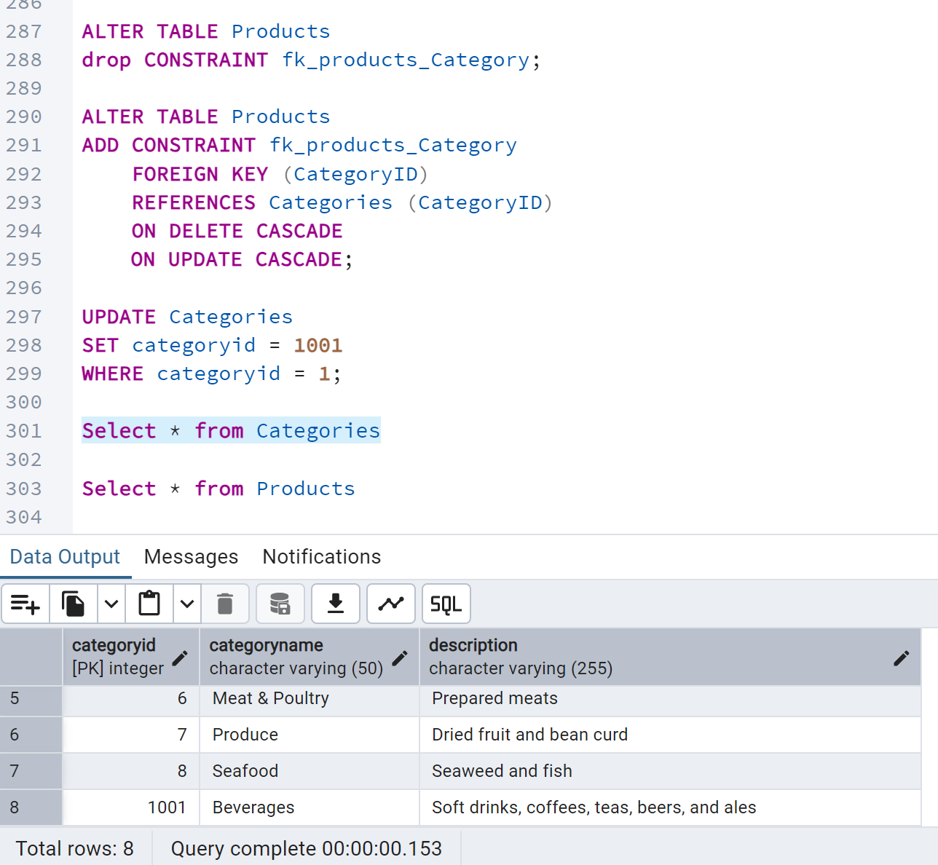

Product table

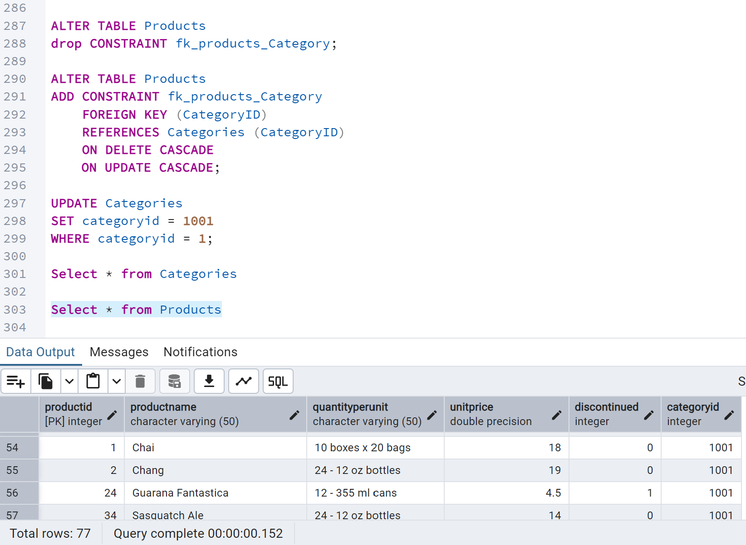

---------Delete the categoryID= “3” from categories.----

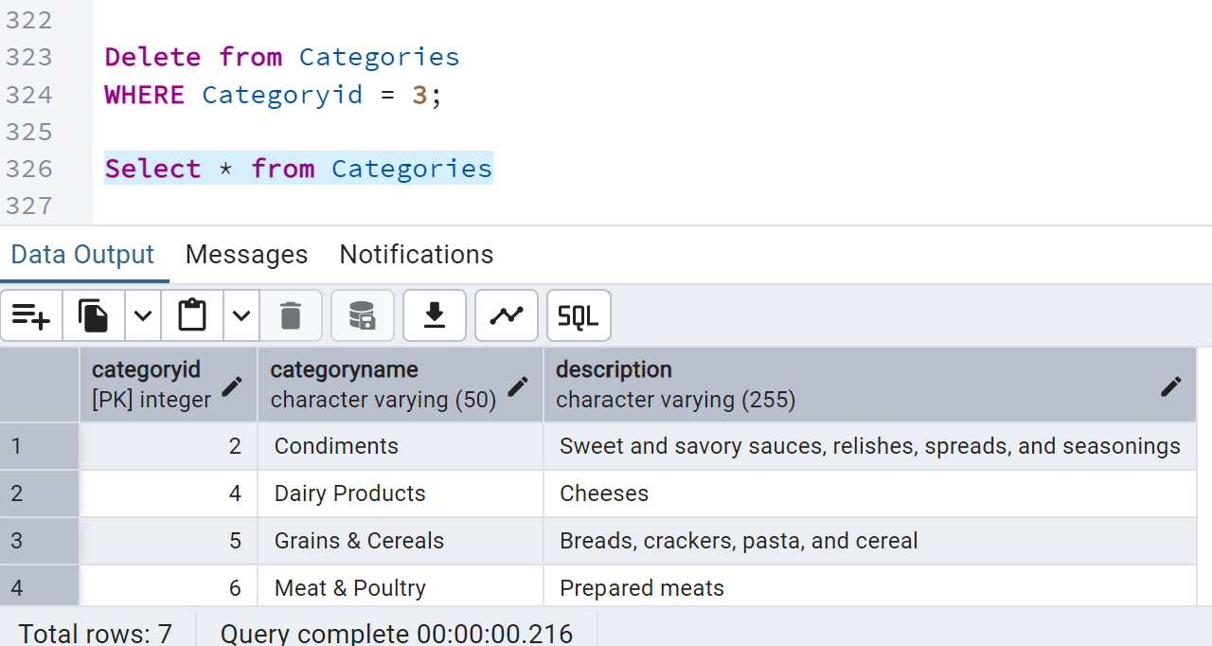

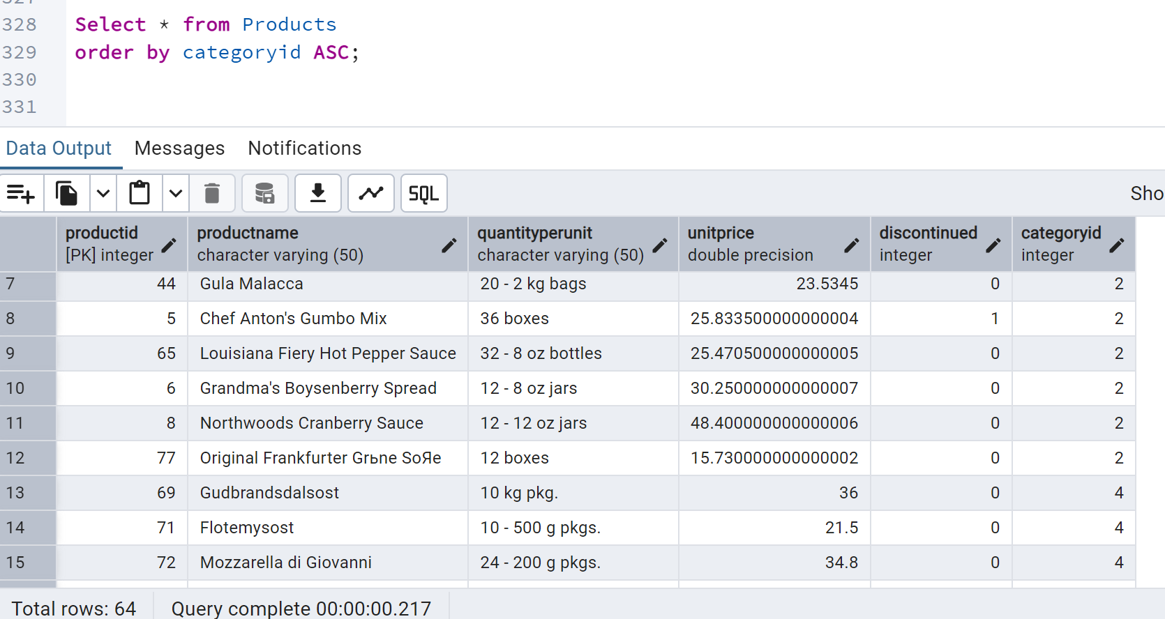

Q.4

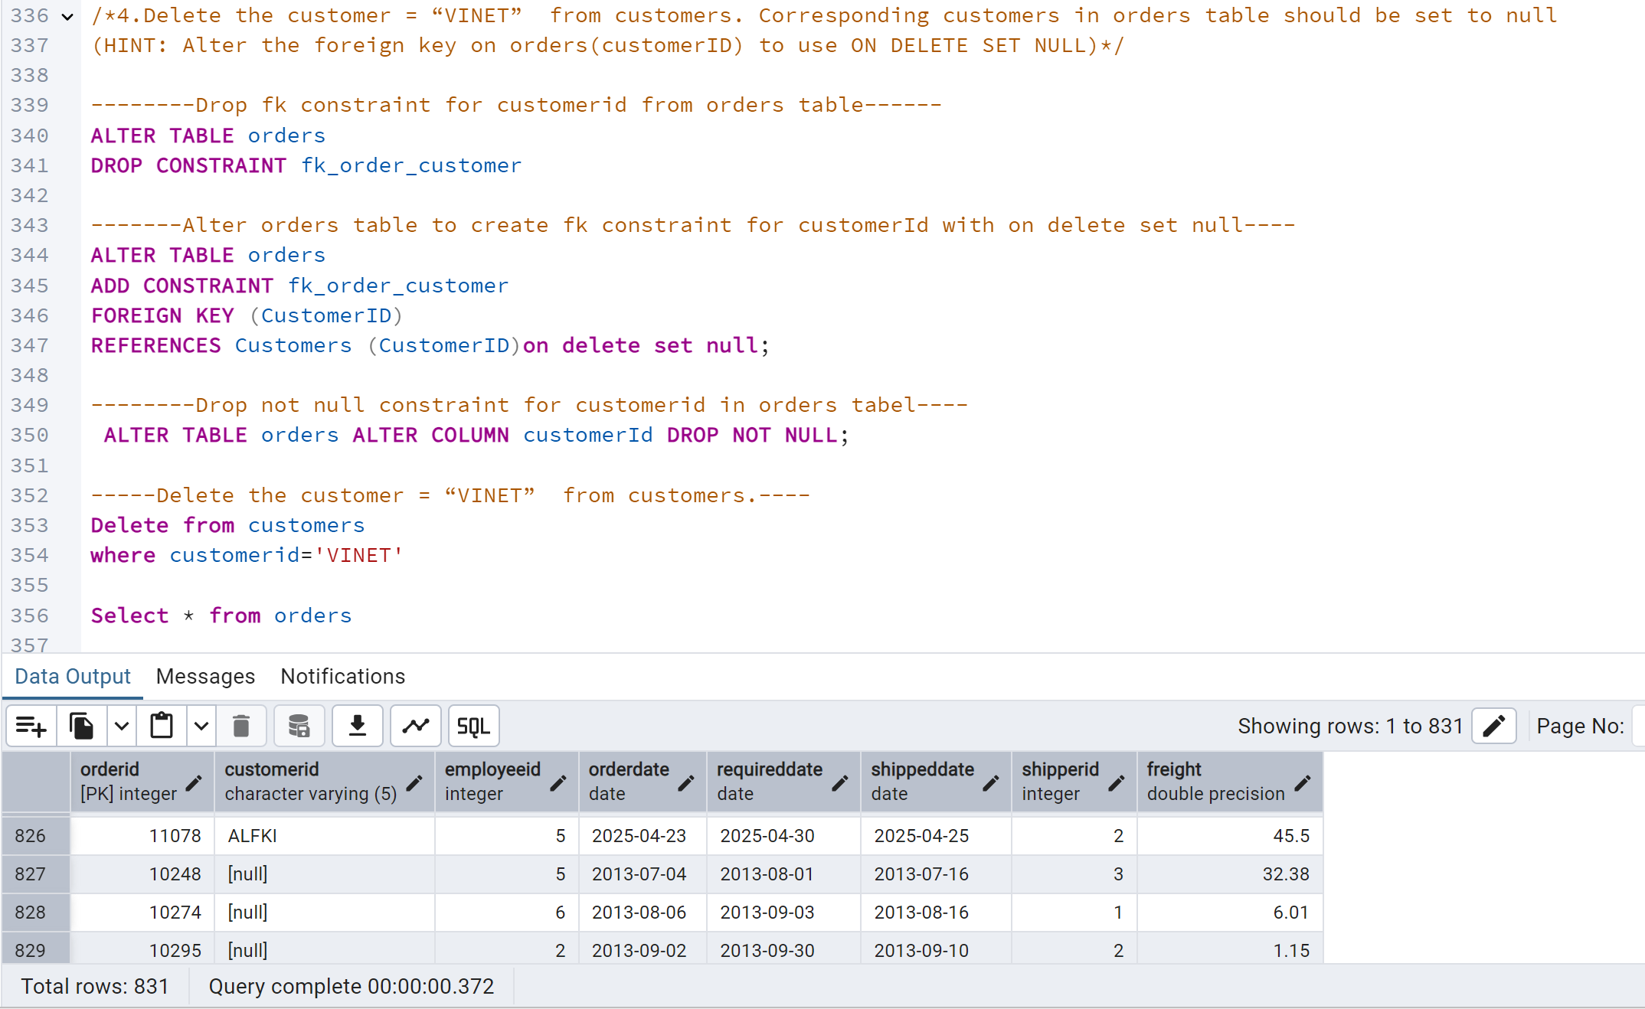

Q.5

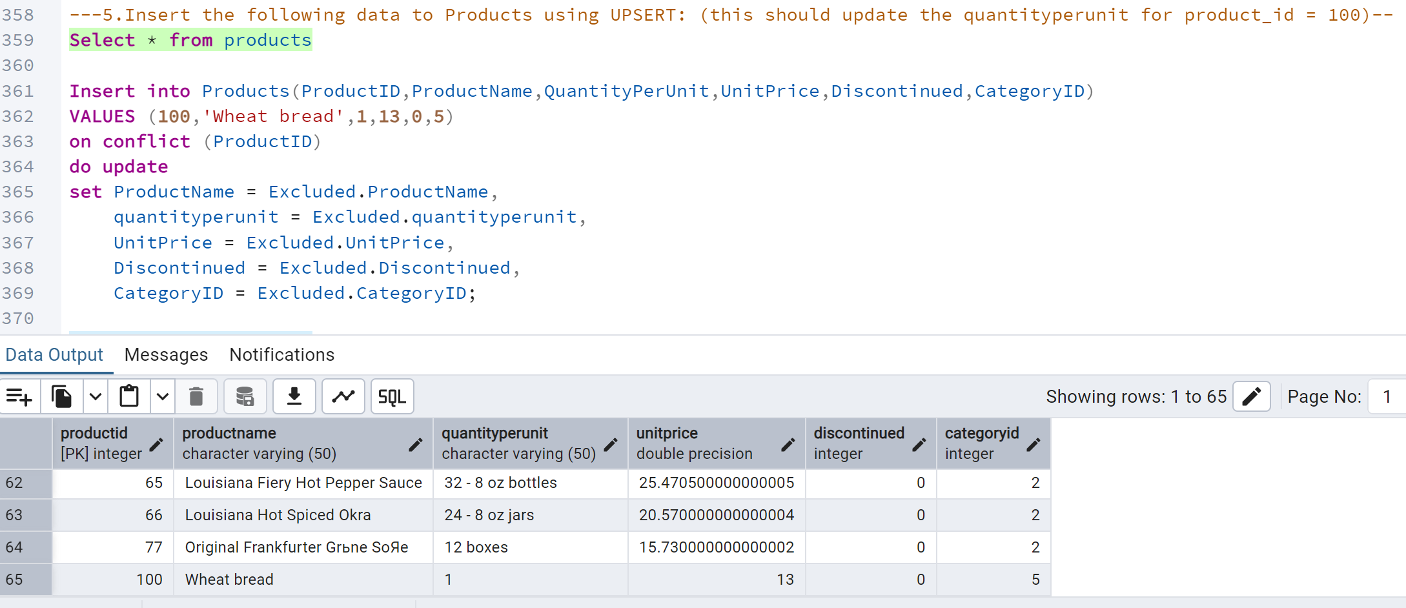

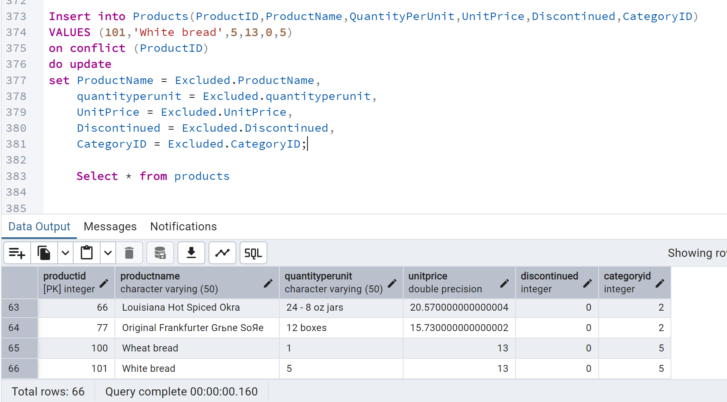

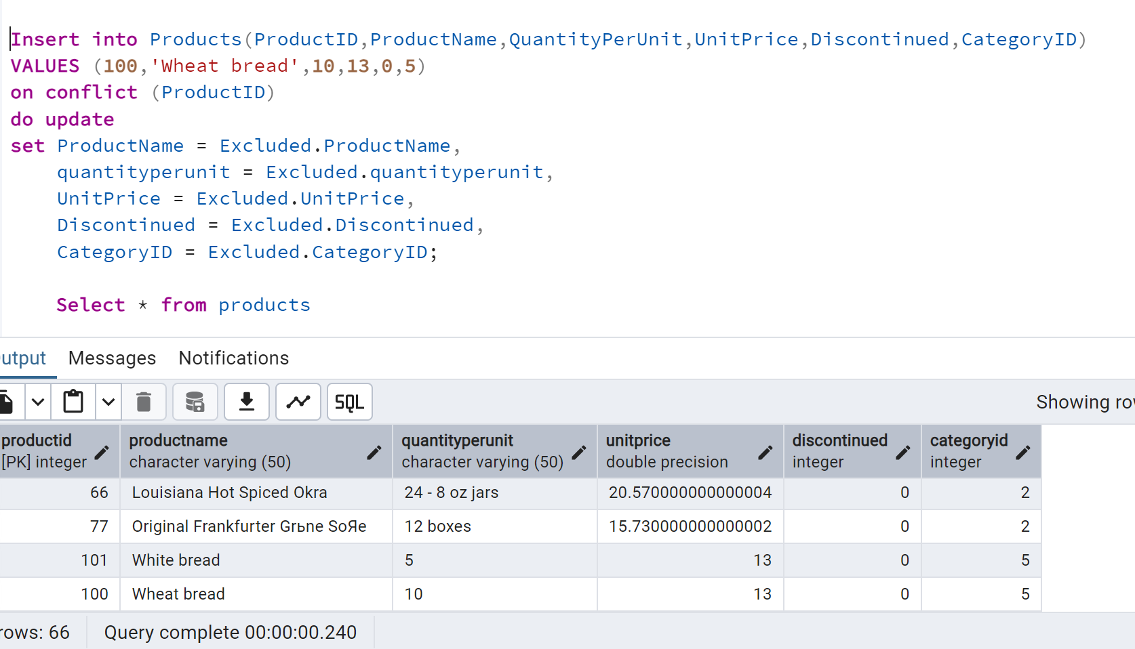

Q6.

Q7. Usingnew Northwind database

 List all orders with employee full names. (Inner join)

